**AIM:** To write queries to implement backup and monitoring in mongodb

**CODE:**

Query 1: mongodump

Query 2: mongorestore ./dump/

Query 3: mongodump --db=employee

Query 4: mongorestore --db employee dump/employee

Query 5: mongodump --db student --collection Details

Query 6: mongorestore --db student --collection Details dump/student/Details.bson

Query 7: mongostat

**OUTPUT:**

**Query 1:**

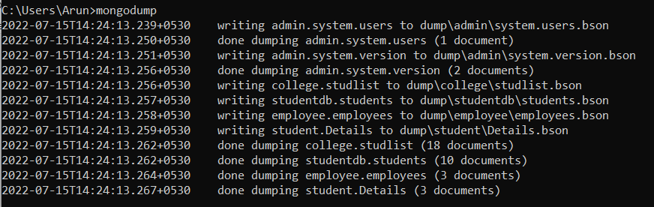

**Query 2:**

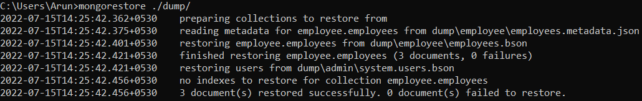

**Query 3:**



**Query 4:**

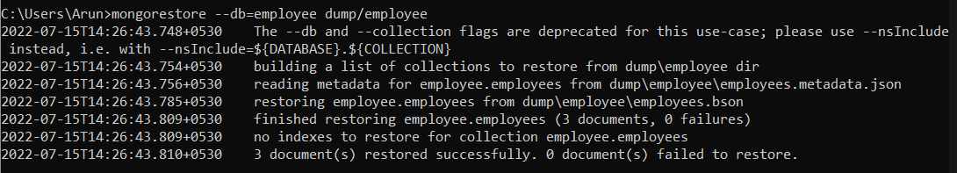

**Query 5:**



**Query 6:**

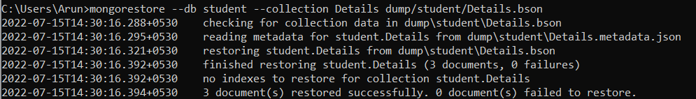

**Query 7:**

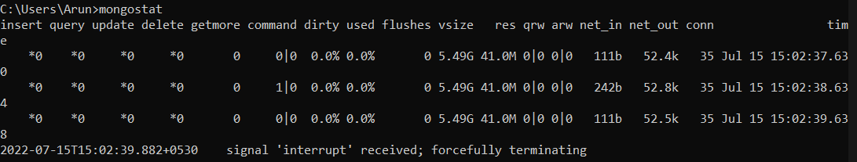

**RESULT:** Query processed successfully and output obtained

**AIM:** To write queries to implement users and roles in mongodb

**CODE:**

Query 1: use student

Query 2: db.createUser({user:"amal",pwd:"1234",roles:[{role:"readwrite",db:"student"}]})

Query 3: show users

Query 4: show roles

**OUTPUT:**

**Query 1:**



**Query 2:**

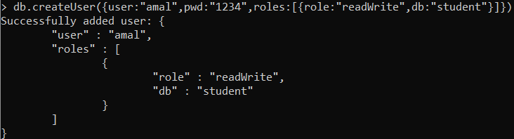

**Query 3:**

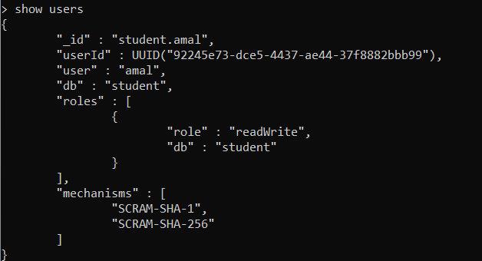

**Query 4:**

